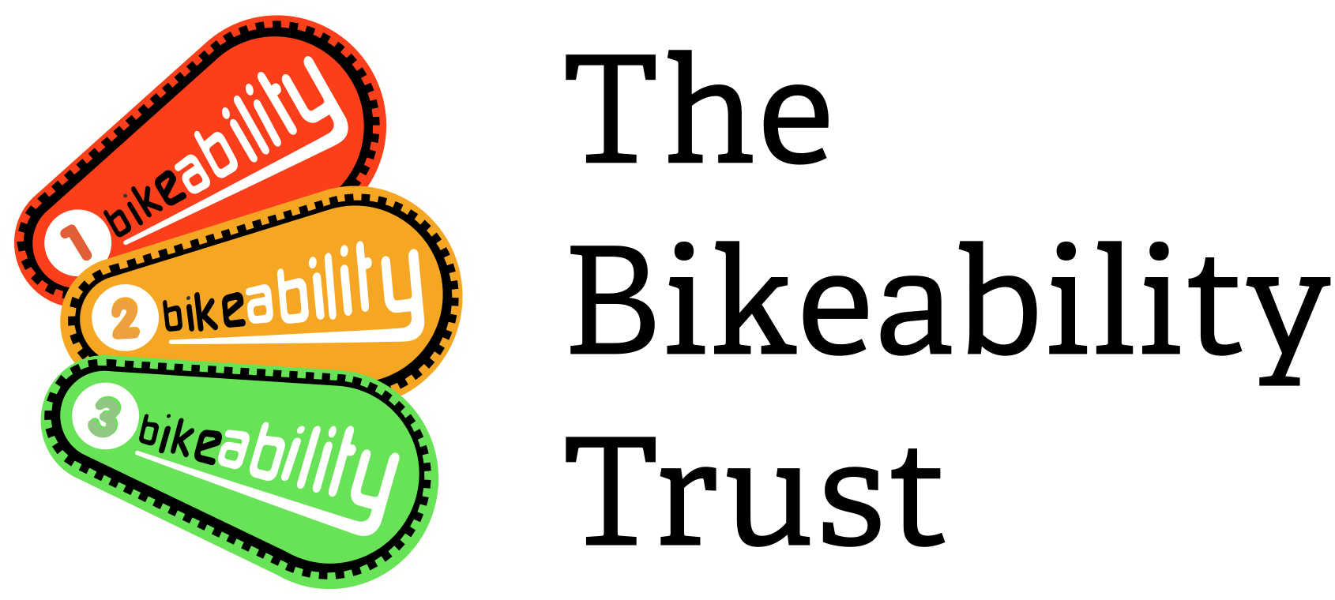
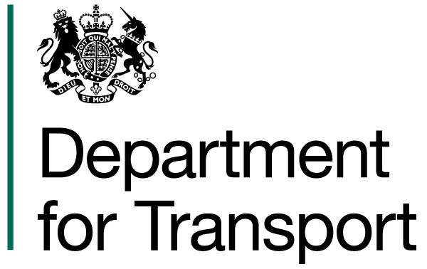
Request to claim cancelled Bikeability training places due to Covid-19 for 2021/22 financial year

Local Authority/School Games Organiser name
Contact name
Contact number
Contact email address
Name of outsourced training provider(s) (if applicable)

We have secured support from Department for Transport to continue to pay for courses affected by COVID. Please use this form to claim for schools who cancel entire courses due to COVID-19 after 1 April 2021. You will be contacted to confirm if you claim has been successful, at which point you will be instructed how to process the claim through Link. Your claim will be pad at 100% of DfT funded rate and will not be deducted from your 21/22 allocation, it will be funded from a central Bikeability budget.

For courses which still run, but with lower attendance due to COVID concerns, any reduction in numbers of children attending courses can be claimed through the 10% on attendance rule as detailed in your grant terms and conditions. Please continue to use the Bikeability Delivery Guide with the COVID addendum to ensure you are following guidance.

- Evidence required.
We are also simplifying the evidence needed to make the claim, but we will still require this evidence in order to show audit against budget. Any claims submitted without evidence will not be able to be paid. Please ensure you include this to reduce the admin time on processing claims.

You must include the following evidence for us to consider your claim:

- Email or letter from the school to confirm the cancellation. This must include all of the following:
  - course date
  - module
  - number of children booked on the course
  - confirmation that the cancellation was as a result of COVID concerns in the school

The easiest thing to do is to ask schools to reply to the original booking you made with them confirming they are cancelling because of concerns around COVID cases.

- Email from Training Provider
  - confirming the names of each of the instructors due to deliver the course and
  - confirmation that the instructors due to deliver the cancelled courses will be paid at full course cost and were not reassigned to other work on the cancellation dates

- Cancellation details.

Please complete the table below which should match the evidence attached from the school.

School name | Delivery dates cancelled  (to /from) | Level/Module | Number of children booked on the course | Names of all the instructors booked to deliver the course

- Summary of your claim

Please complete the summary of your claim in the table below.

Claim 1 | 100% of DfT funding per training place (£) | Number of places claimed | Total funding claimed (£)
Level 1 | £10.00
Level 1/2 combined | £45.00
Level 2 | £45.00
Level 3 | £45.00
Bikeability Balance | £28.00
Bikeability Learn to Ride | £24.00
Total

- I confirm that I have completed the form and attached the evidence required in section 1 in order for my claim to be considered.
I confirm that the information may be shared with the Department for Transport and HM Treasury when auditing COVID claims.

Name

Position

Please email the completed form and evidence to grants@bikeability.org.uk and we will consider your request and inform you of our decision within 2 weeks of receiving the request and supporting evidence. You will be contacted to confirm if you claim has been successful, at which point you will be instructed how to process the claim through Link.

