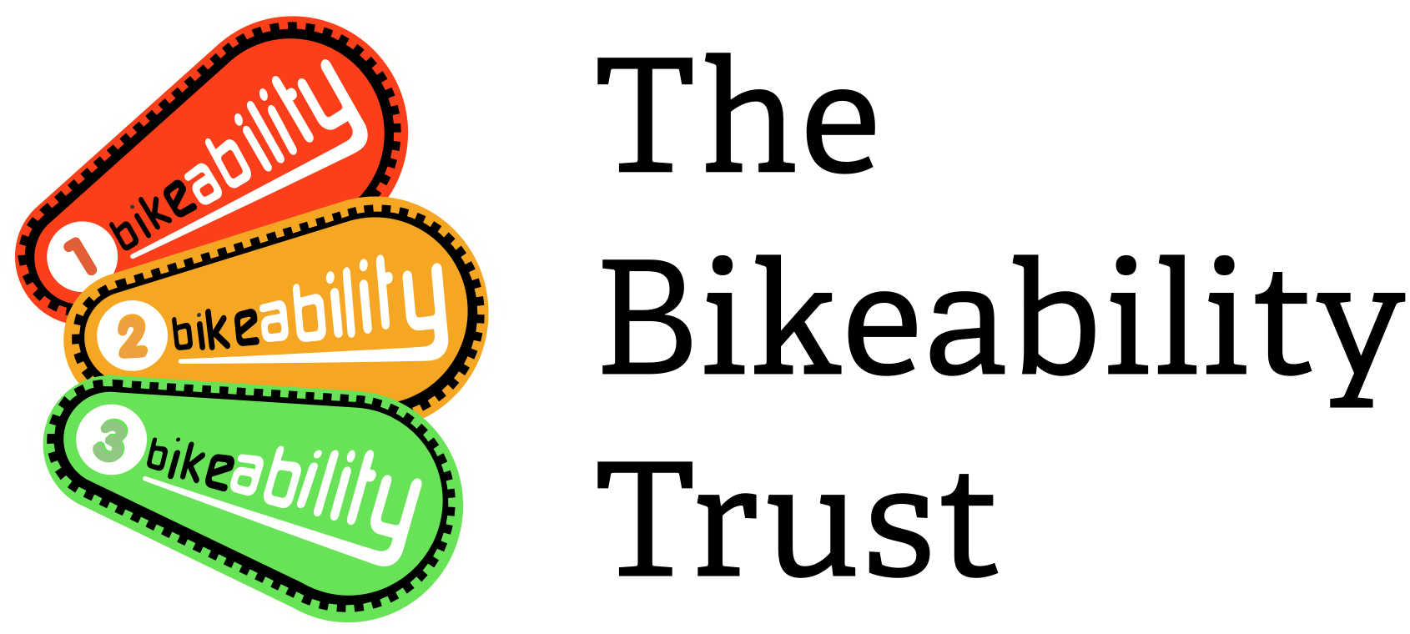
Request to claim cancelled places on Bikeability training courses due to Covid-19 for February and March 2022

Local Authority/School Games Organiser name
Contact name
Contact number
Contact email address
Name of outsourced training provider(s) (if applicable)

We have secured a limited pot of funding from the Department for Transport to pay for places on courses that have reduced attendance due to COVID in February and March 2022. Please use this form to claim for schools where courses have been run with reduced numbers when comparing to booked places due to COVID-19 in February and March 2022. You will be contacted to confirm if your claim has been successful, at which point you will be instructed how to process the claim through Link. Your claim will be paid at 100% of DfT funded rate and will not be deducted from your 21/22 allocation, it will be funded from a central Bikeability budget. The funds are limited so this is on a first come first served basis available in February and March 2022 only.

Please do not use this form for courses that are cancelled entirely. You are able to claim for this, but through a different form.

As 10% of attended value (up to booked value) can be claimed through general cancellation allowance, this may need be deducted from the numbers when we calculate your claim (dependant on the number of cancellations not related to COVID). Please complete the table of details on the next page and email this with the required evidence to grants@bikeability.org.uk and we will reply with the number of places you are able to claim for.

Please continue to use the Bikeability Delivery Guide with the COVID addendum to ensure you are following guidance.

- Evidence required.
We require this evidence in order to show audit against budget. Any claims submitted without evidence will not be able to be paid. Please ensure you include this to reduce the admin time on processing claims.

You must include the following evidence for us to consider your claim:

- Email or letter from the Head Teacher/Assistant Head Teacher at the school. This must include all of the following:
  - title of person sending email/letter
  - course date
  - module
  - number of children booked on the course
  - number of children that did not attend as a result of COVID (template email to send to school on the next page).

- Email from training provider
  - confirming the names of each of the instructors due to deliver the course and
  - if payment to instructors is made on the basis of numbers attending, confirmation that the successful claim will be used to pay instructors for the children missing from the course due to covid

- Cancellation details.

Please complete the table below which should match the evidence attached from the school.

School name | Delivery dates  (to /from) | Level/Module | Number of children booked on the course | Number of children attended | Number of places cancelled due to covid | Instructors Names

- I confirm that I have completed the form and attached the evidence required in section 1 in order for my claim to be considered.
I confirm that the information may be shared with the Department for Transport and HM Treasury when auditing COVID claims.

Name

Position

Please email the completed form and evidence to grants@bikeability.org.uk and we will consider your request and inform you of our decision within 2 weeks of receiving the request and supporting evidence. You will be contacted to confirm if you claim has been successful, at which point you will be instructed how to process the claim through Link.

Example of email to be sent to the school for confirmation:

Dear XX

We have secured support from the Department for Transport to claim for courses that have reduced attendance due to COVID. In order to support our claim, please can we ask that the Head Teacher/Assistant Head Teacher confirms the following details either on a letter or email from Head Teacher/Assistant Head Teacher’s (to include name and job title):

Course Level =
Course Date =
Total number of children originally booked onto the course =
Total number of cancellations for reasons not related to COVID =
Total number of cancellations for reasons related to COVID =

Kind Regards
XX

Claim Calculation Form (FOR OFFICE USE BY THE BIKEABILTY TRUST GRANTS TEAM)

Number of children booked onto course A

Number of children attended B

Total cancellations (A – B) C

Total amount to be claimed through normal cancellation allowance (B x 0.10) – no decimals, always round down D
- Numbers cancelled for covid reasons (confirmed by Head/Assistant Head Teacher) E

- Numbers cancelled for reasons not related to covid F
(E and F should total C)

Figure D minus figure F (if lower than zero, mark as zero) G

Figure E minus figure G –places that can be claimed H

- Summary of your claim (FOR OFFICE USE BY THE BIKEABILTY TRUST GRANTS TEAM)

Claim 1 | 100% of DfT funding per training place (£) | Number of places claimed | Total funding claimed (£)
Level 1 | £10.00
Level 1/2 combined | £45.00
Level 2 | £45.00
Level 3 | £45.00
Bikeability Balance | £28.00
Bikeability Learn to Ride | £24.00
Total

