**The Bikeability Trust’s Innovation Fund**

SEND Pilot Project

*Dissemination Report*

1 Introduction 3

1.1 Timeline 3

2 The projects 4

2.1 The bid selection process 4

3 Learnings from the projects 7

3.1 Project statistics 7

3.2 Impact of the projects: key findings 7

3.3 Project feedback: key learnings 9

4 Next steps 13

5 Appendices 14

5.1 The projects 14

5.2 Case Study 1: London Borough of Greenwich 22

5.3 Case Study 2: Newsome SGO 23

5.4 Case Study 3: Bolton Council 24

# Introduction

A portion of the Trust’s restricted income, accrued through commercial partnerships and charity cost savings, is held in our ‘Innovation Fund’. This Fund is governed by the Bikeability Trust’s Board of Trustees with a purpose to invest in strengthening Bikeability delivery and effectiveness. Two of the core objectives of the Innovation Fund are as follows:

1. Piloting new forms of Bikeability training with a focus on children who do not currently access Bikeability
2. Piloting initiatives that remove barriers to access to participating in Bikeability

A key issue for the Innovation Fund to address is the low uptake of Bikeability by children with special educational needs and disabilities (SEND). There exists a significant disparity between children that take part in Bikeability, and the percentage of children with SEND. The proportion of Bikeability training delivered to children and young people who have been identified as having some form of SEND is not representative of the number of children that the Department for Education lists with SEND.

To address this issue, a proportion of the Innovation Fund has been used to run a pilot project. Referred to as the ‘SEND Pilot Project’, the work seeks to fulfil four core objectives:

1. To gather information on training costs for children with SEND to build this into future grant funding programmes
2. To compile case studies/best practice with innovative training solutions for children with SEND
3. To increase the number of children trained with SEND
4. To ensure accurate delivery records of children trained with SEND

To achieve this, the Trust invited innovative bids from the industry, subsequently awarding a total sum of £275K to 18 applicants. These winning applicants had submitted a well-designed, collaborative proposal that demonstrated a realistic opportunity to increase SEND participation in Bikeability within their local area.

The following dissemination report provides detail on the projects that took place and shares key learnings that were gained during the projects’ duration. Following this report, further resources including a continued professional development (CPD) module, and a toolkit will be developed by the Trust and key industry individuals. These resources will assist the industry in increasing the participation of children with SEND in Bikeability.

## 

## Timeline

Figure 1 presents the timeline of the SEND Pilot Project. Please note, original timings for these projects were subject to considerable disruption due to COVID-19.

|  |  |
| --- | --- |
| **Date** | **Milestone** |
| 2020 - November | Innovation Fund bidding round opens. |
| 2021 - January | Deadline for bid submission. Innovation Fund Project Board scoring and decision making. |
| 2021 - February | Communication to successful bids and awards granted. |
| 2021 - March | External evaluation commissioned with Cardiff University & Oxford Brookes. |
| 2021 - April | Pilot projects commence. |
| 2021 - October | Majority of pilot projects complete. External evaluation report complete. |
| 2022 - February | External evaluation report findings presented at Bikeability Conference. |
| 2022 - March | All outstanding projects now complete. |
| 2022 - May | Dissemination of key learnings to industry. |

# The projects

## The bid selection process

A total of 30 bids were received by the Bikeability Trust. To select the winning bids, a thorough selection process was implemented. This comprised of a broad set of evaluation criteria, and a scoring system. Each bid received a total score dependent on its fulfilment of these criteria. In addition to the evaluation criteria, the final selection of winning bids had to offer a good level of representation geographically.

### Evaluation criteria

The evaluation criteria fell under six umbrella categories: innovative delivery approaches, long-term impact, partnership models, value for money, evaluation process, and alignment with the objectives and outcomes of the fund. A scoring system was developed based on a five-point scale ranging from ‘unsatisfactory - needs significant development’ to ‘comprehensively addressed’. Points were scored under each category.

**Innovative delivery approach**  
Successful bids presented achievable plans for an innovative delivery model, whilst also providing detailed insights as to how schools and specific groups of pupils would be identified and recruited.

**Long-term impact**  
Key criteria under the category of ‘long-term impact’ included the presence of opportunities to upskill instructors, the development of connections with external organisations that could lead to long-term impacts, and whether the delivery model presented in the bid could be sustained beyond the innovation fund’s scope. Points were also awarded if it was believed the delivery model could be replicated, or whether there was an opportunity of embedding it into mainstream Bikeability.

**Partnership models**  
Critical to a successful bid was a carefully considered partnership model that included comprehensive detail on the grant recipient partnered with, the workings of the partnership and the presence of a stakeholder with SEND experience. Bids that scored highly were also able to demonstrate good levels of collaboration with stakeholders that would contribute to networks and hubs of lesson learning or equipment sharing, and partnerships that were sustainable and provided opportunity to the organic upskilling of instructors.

**Value for money**  
Bids provided detail on the total amount bid for together with a breakdown of how the funds would be used. This was evaluated together with specific metrics such as the cost per place (accounting for the training hours designated to the place).

**Evaluation process**  
The presence of an evaluation process was an important criterion in the selection of winning bids. Points were awarded based on the presence and quality of monitoring and data collection plans, and steps that would be taken to disseminate project learnings and advice on good practice at the end of the pilot.

**Meets criteria, and aligns with Fund’s objectives**  
Scores were determined by the presence of a clear, quantified and costed delivery plan, well-evidenced information of the scale of under-representation of the selected group in cycle training sessions, clear timescales, and expected outcomes for individuals, parents and schools. Furthermore, the bid had to demonstrate the achievement of one or more of the following objectives;

1. For grant recipients to deliver new Bikeability places to children with SEND in mainstream (but whose additional needs mean that they would currently be excluded from Bikeability training because it is not possible for them to train in the same group as mainstream children) or specialist provision.
2. To acquire specialist expertise and upskill their current workforce in a manner that will directly enhance their ability to train children with SEND and increase the uptake in their area.
3. For grant recipients with some experience of delivering Bikeability to children with SEND to increase and expand their delivery to increase uptake.

### Geographical spread

The representation of the winning bids was a key consideration as it was important to ensure that the funding was distributed as evenly as possible. Not only was it important that the winning selection of bids performed well under the evaluation criteria, but that together, they represented good geographical coverage across England, including London Boroughs. This can be seen below in figure 2, which presents the location of the 17 projects that were awarded funds, across the country.

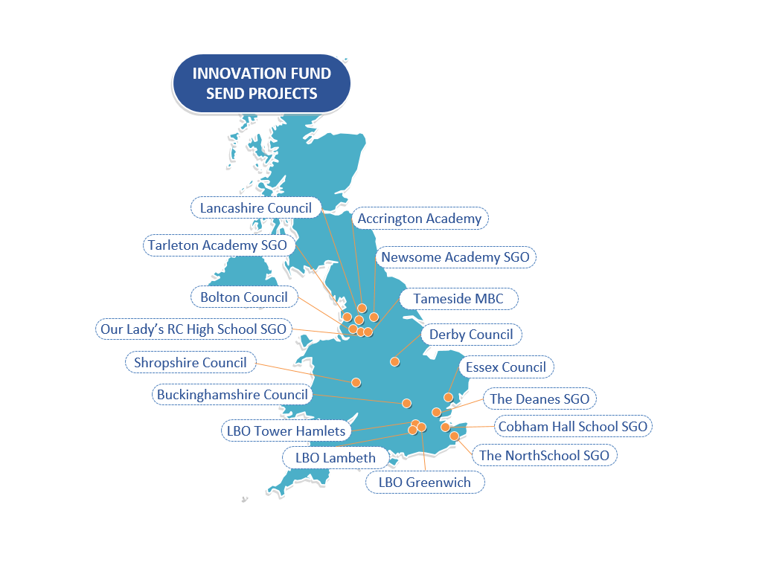 ***Figure 2:*** *The geographic spread of projects*

In addition to geographic spread, the selection of winning bids had to show that together, they would target a range of SEND categories. Bidders were asked to identify the SEND groups that they planned to reach with their project. Between the projects, the following SEND categories were covered:

* Moderate learning difficulty
* Severe learning difficulty
* Profound and multiple learning difficulty
* Autistic spectrum disorder
* Hearing impairment
* Physical disability
* Social, emotional and mental health

# Learnings from the projects

The following section details the impacts and key learnings from the projects, whilst also highlighting some examples of innovative practice. Firstly, key statistics collated from all projects are presented to provide an overview of the projects’ reach and high-level impact. The following two sections provide a deeper insight into the impact of the projects, and the key learnings that have been gained.

## Project statistics

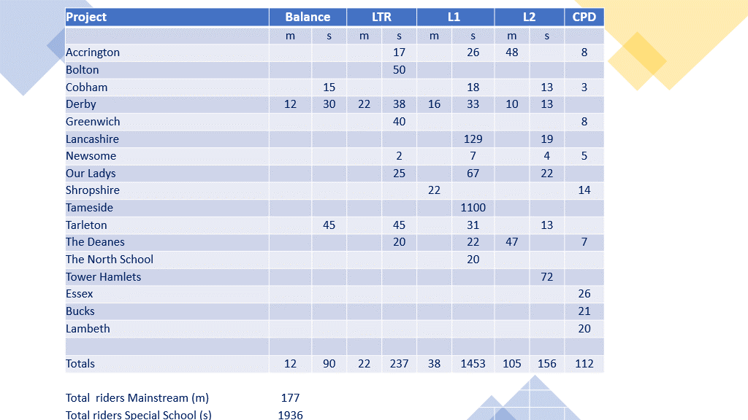

***Figure 3:*** *Pilot Project Statistics*

## Impact of the projects: key findings

**Summary of key findings**

* Cycling improved in the vast majority of the riders, even for those with severe learning difficulties.
* Teachers reported positive effects on riders’ general learning, general confidence, general self-esteem and general well-being.
* Parents reported feeling more confident in their child’s ability to cycle independently.
* Years of instructor experience of cycle training children with SEND seemed to be valuable, and further training was considered useful.

An evaluation of 12 of the projects was independently undertaken through the distribution of three questionnaires by an external evaluation team[1]. These questionnaires were used to survey responses from instructors who either received training on working with children with SEND and/or actually trained children with SEND, teachers of children with SEND who were involved with the training in some capacity, and parents of children with SEND who participated in the training. The overall purpose of the evaluation was to determine principles for best practise, capture parental, teachers’ and instructors’ perceptions and identify specific training requirements in the delivery of cycle training for children with SEND.

Collectively, the SEND projects accommodated a range of specific education needs, with children from different SEND categories typically trained together. The overwhelming message from the instructors, the parents and the teachers was that the SEND projects were a huge success. Cycling improved in the vast majority of the children who took part in these sessions. This was true even for those with severe learning difficulties who attended special schools. All of the instructors running cycle training with children with SEND reported feeling confident in their understanding of the children’s needs and felt they had sufficient information about the children, which enabled them to differentiate the training for each child. The majority of instructors reported training children in small groups with some also using specialist equipment.

Learn to Ride, Level 1 and/or Level 2 training was delivered, and instructors reported high levels of engagement and enjoyment amongst the children. This was supported by teachers who very much indicated that they would welcome more training of this type for children with SEND and who additionally reported positive effects on general learning, general confidence, general self-esteem and general well-being, and to a slightly lesser extent behaviour and social skills. This wider impact of the cycle training was also reported by parents who spoke about positive impacts on confidence and well-being.

Nearly all the instructors stated that they were able to tailor the training to the needs of the child and this child-centred approach was considered very important to instructors, parents and teachers.

Years of instructor experience of cycle training children with SEND seemed to be valuable, and further training was considered useful. According to parents, prior to training the majority of the children were able to cycle using some sort of bicycle, although not always independently. After the training, the majority of parents reported feeling more confident in their child’s ability to cycle independently. All parent respondents stated that they would recommend the training that their child received to parents of children with similar needs. Although the majority of parents stated that they plan to cycle more as a family as a consequence of the training, the biggest perceived barrier was their child’s lack of confidence, fear and/or anxiety.

## Project feedback: key learnings

In addition to the evaluation questionnaires, feedback from the projects was collated in the form of reflection and impact reports, post-course evaluation surveys, and regular project updates sent to the Trust by the project teams. Whilst some of the feedback is highly project-specific, useful insights common across a range of the projects could be drawn. Presented below are a set of broad learnings that can be used to inform and support the delivery of Bikeability to individuals with SEND and will feed into the Trust’s development of further resources for SEND delivery.

**Summary of key findings**

* Engagement prior to the training can increase rider comfort, enable sessions to better cater for specific needs, and help to set realistic expectations of the training outcomes.
* Sessions are most effective when they are shorter (than traditional Bikeability sessions), interspersed with regular breaks and part of a delivery that holds regular sessions over a longer time period.
* Flexibility in relation to the timetabling of a session enables the instructor to effectively align activities with the mood, energy level and attention span of the riders.
* The consistency of instructor increases riders’ familiarity and thus level of comfort.
* Higher instructor-to-rider ratio is often necessary, as is the use of smaller groups.
* Extra consideration is needed for the accessibility and the size of the space in which the delivery is held.
* Rider development should be approached in a flexible and adaptable manner.
* Adapted cycles can be key to increase inclusivity. Consider the need for a wide variety of adapted cycles and the cost of these cycles for the timespan of the delivery, in the budget.
* An instructor ‘buddying’ system can increase instructor confidence and present a valuable learning experience.
* CPD on cycle training for SEND individuals is valuable and can lead to improved confidence levels amongst instructors when the theory is paired with practical activities.

### Bikeability delivery in schools

**Involvement of others**

Value was placed on taking time to speak directly with the school prior to the Bikeability delivery, and preferably with individuals who know the riders well. Information on the riders’ specific needs, traits and the expectations of the training could therefore be shared in advance, enabling instructors to prepare and go on to deliver training sessions well-suited to the riders. Interactions prior to a delivery were not limited to schools, as some projects took the opportunity to reach out to parents and the riders directly. Bespoke letters were perceived to be a useful method of communication to parents of riders, equipping them with the means to prepare their child for the delivery. Further projects placed value on sessions that familiarised riders with the equipment they would be using during their training and believed it to be an effective method of increasing rider comfort.

Feedback from various projects highlighted the value of the presence of school staff during the delivery. Not only could staff provide additional information on the needs of the riders, but they could also help the instructors understand the outcomes that could be expected from the training. Furthermore, staff were reported to provide effective support during the training sessions, attending to riders’ needs and improving their level of comfort as they offered familiar faces to the riders.

Two projects used additional ways of involving others during the cycle training. One project used photos and livestreaming to involve riders’ parents and carers who wished to be a part of their child’s cycle training experience but were unable to be present physically. This facilitated the positive engagement of the parent/carer in the cycle experience of their child. Another project found that holding a SEND-focused session at the same time as classmates were undertaking a traditional Bikeability session boosted the morale of those in the SEND session.

Following the completion of a delivery, some project partners harnessed the opportunity to gather feedback. This took the form of simple surveys that were emailed to the parents or carers of the riders. This proved to be a valuable method of gathering insights into the impact of training and highlighting ways in which the training could be adapted to improve it further. With the drive to ensure the impacts of the training were sustained, two projects took further action after the delivery was complete. For one project, this resulted in the sourcing of funding to facilitate a return to the school with a Dr Bike session. The intended purpose of this was to enable riders to continue their cycling journey on well-functioning cycles. A further project created a proposed action plan referred to as an ‘exit route’, designed for schools who had just received a delivery. The exit route involved plans to provide training for teachers in ‘rider leadership’, and cycle-maintenance training.

**Time management**

The additional time for the delivery of a SEND-focused session was cited by many as a necessity. Extra time was needed to provide the necessary space for individuals to overcome any mental and physical challenges present. This proved to be particularly important during sessions that involved the use of specialist equipment such as adapted cycles. For example, getting on and off adapted cycles often required more time than had often been planned for in a delivery.

Whilst additional time was important to many projects, the feedback from instructors and project leads often warned against the delivery of long-lasting sessions. Short and frequent sessions proved to be key to effective training. Short sessions interspersed with regular breaks were perceived to be better aligned with the energy levels, moods and concentration spans of many groups. Embedding short sessions in deliveries that were spread over a longer period of time (than of a traditional Bikeability delivery) was perceived to have a positive effect on the development of riders’ cycle skills and their ability to sustain these skills over time.

Aligned with the use of shorter sessions, flexibility was found to be a key ingredient in the delivery of SEND cycle training. Flexibility in relation to the timetabling of the session was important to align the mood, energy level and attention span of the group with the group’s engagement with, and enjoyment of the activities.

**Instructor familiarity and group sizes**

A consistent instructor delivering cycle training to the riders was perceived to be a valuable factor that contributed to riders’ level of comfort, and their cycling development. Having the same instructor holding each session with the same rider or group of riders enabled both parties to develop a familiarity with one another. Whilst increasing the degree of comfort felt by the rider, it also enabled the instructor to become familiar with the rider’s needs and abilities. This equipped the instructor with the information and understanding to design sessions best suited to the riders.

Small group sizes were employed by almost all projects with the primary reason being that this enabled more effective management of additional requirements demanded by the riders. With higher instructor-to-rider ratios than that of a traditional Bikeability delivery, instructors could provide a closer level of support, guidance and encouragement to individuals, many with specific needs. Despite employing this principle, the ratios ranged across the different projects as they were arguably influenced by many different factors. Factors included the level of support required by the riders, and the number of school staff able to attend the session, amongst others. This again highlighted the importance of embedding a flexible approach throughout deliveries as a standardised ratio of instructor to rider could not be realised.

**Space for training**

The accessibility and the size of the space demanded by projects, particularly those that utilised adapted cycles, was a key consideration for many project leads and instructors. Project feedback provided specific examples that highlighted this issue including the need for a space large enough to allow riders to have sufficient control over their cycle, and the need to consider the feasibility of riders to ride their adapted cycle back to the start after completing an on-road outcome. As one project highlighted, this is an important area to consider when conducting risk assessments for SEND deliveries.

**Rider outcomes**

Flexibility proved to be the key theme when considering rider outcomes. Projects found that it was important to not fixate on ‘rigid’ traditional rider outcomes, instead have a flexible and adaptable approach to rider development. Riders should be challenged but what should remain important to the session is the sense of fun and the level of rider engagement.

**Adapted cycles**

Adapted cycles were key to maximising the inclusivity of many of the projects. Feedback on the topic of adapted cycles emphasised the need for a variety of adapted cycles to suit varying needs and the need to consider the cost of these cycles in the budget. The cost was a particular concern when holding frequent, short sessions that were part of a longer-term delivery, as the cycles had to be available for each session whilst also being transported to and from the site at the start and end of a session. Concerns were raised on the longevity of the rider’s journey were they not able to access an appropriate adapted cycle beyond the Bikeability delivery.

### Instructor CPD

**Mentoring system**

Mentoring or ‘buddying’ systems were used by many of the projects. This consisted of pairing an instructor experienced in the delivery of Bikeability to SEND individuals, with a less experienced instructor. The provided a valuable learning opportunity for the less experienced instructor and proved to be an effective method in increasing their confidence in delivering to SEND individuals. The practice of this varied between projects. One project had an experienced SEND expert on standby, ready to answer questions and offer tips to instructors onsite holding the deliveries. Other projects had both the experienced and lesser-experienced instructor onsite delivering the cycle training together.

**Format of the CPD training**

The format of instructor CPD projects varied between the projects. All projects held sessions that focussed on theory concerning SEND and cycle training, whilst some also offered instructors an opportunity to observe the delivery of SEND cycle training, and/or take part in the delivery of these sessions. Feedback from instructors that took part in CPD sessions emphasised the value of a practical component so as to build confidence in practicing what had been learnt during sessions on theory. Instructor confidence was also increased after being given the opportunity to try out a range of adapted cycles. Feedback from one project highlighted the positive impact such an opportunity had on instructors’ ability to put themselves in the shoes of a rider who uses an adapted cycle and for them to develop a better understanding of how they might approach the delivery of sessions using such equipment.

**Use of resources**

A SEND-focused instructor handbook was produced for one of the projects and served as a highly useful reference document for instructors. The handbook provided detail on types of SEND groups that an instructor may come across, ways in which certain SEND characteristics may play a role in the cycle training, and insightful tips associated with that SEND type that when used, could lead to a more effective and impactful delivery. The handbook received high praise and will play an important role in the development of further resources for the delivery of Bikeability to individuals with SEND.

Another project developed a CPD module to develop instructor understanding and proficiency in the delivery of Bikeability training in a SEND setting. The module included useful background information looking at theoretical frameworks and language surrounding disability, whilst also highlighting types of SEND groups and how instructors can best achieve outcomes through reasonable adjustments and assistance. This will be extremely valuable in the development of future resources.

# Next steps

Following the completion of all the projects, and the collation of a valuable set of learnings, resources designed to assist the delivery of Bikeability to individuals with SEND have and will continue to be developed.

Resources that will follow include a CPD resource and a toolkit for industry use. This will help to equip the industry with the knowledge and skills to confidently tailor cycle training effectively to children with SEND.  
  
**SEND top-up funding**

A cost analysis of the 17 pilot projects has been carried out. Following this, the Department for Transport agreed to provide a pilot SEND ‘top-up’ fund to enable grant recipients and their training providers to deliver inclusive cycle training to children who may not have been able to access Bikeability training.

This funding will help to ensure the necessary resources are available to deliver cycle training to children with SEND in small groups with a higher instructor-to-rider ratio, where this is needed. It will also enable instructors to access specialised equipment for their deliveries. In piloting this approach, the Trust will be able to gather further evidence to develop best practise when planning and delivering SEND sessions in both mainstream and special schools. This will support the case of a SEND top-up fund as part of the future programme approach.

**CPD**

A new CPD module will be developed, focused on delivering cycle training to individuals with SEND. This will build on the learning from several of the Innovation projects and will initially comprise of online content that can be accessed by all Bikeability instructors. The CPD module will act as a gateway to other interactive courses and development opportunities and will be designed to support and further develop the industry’s knowledge, skills and confidence when delivering cycle training to SEND individuals.

**Toolkit**

A toolkit will be developed alongside the CPD module. This will have identified key areas in which further support and training would be useful and will signpost to existing resources that can be used by individuals to increase their knowledge and confidence in these areas.

Throughout the process of the SEND projects, a significant amount of knowledge and experience has been gained by a range of individuals. The Bikeability Trust will seek to engage with as many of these individuals as possible to ensure that the resources produced capture the valuable insights and knowledge these individuals hold.

# Appendices

## The projects

In total, 17 bids were awarded a share of the funding to pursue their projects. The following section introduces the projects, providing key information including the target group, the setting in which the project took place, the focus of the project and the stakeholders involved.

|  |  |  |
| --- | --- | --- |
| **Accrington Academy SGO Project**  The Accrington Academy project utilised existing facilities and equipment at a special school to increase the delivery of Bikeability. This included the delivery of modules Learn to Ride and Level 1 in special schools, and Level 1 and 2 in mainstream schools.  Instructor CPD was delivered by their Special Educational Needs Co-ordinator at Accrington Academy and covered different types of disability, how to best adapt sessions to suit this disability and how to understand the needs of each participant. | **Project Partners**  Whiteash Special School, Broadfield Special School, Hyndburn and Ribble Valley SENCO network, Pennine Active Cycle Delivery, Hyndburn and Ribble Valley School Sports Partnership | **Location**  Hyndburn and The Ribble Valley, Lancashire |
| **Focus**   * Instructor CPD * Learn to Ride * Bikeability Level 1 * Bikeability Level 1 and 2 combined * Bikeability Level 3 | **Target group**  Children with SEND and instructors. |
| **Setting**  Special schools and mainstream schools |

|  |  |  |
| --- | --- | --- |
| **Bolton Council Project**  The Bolton Council project focused on scaling up existing disability cycling provision throughout the borough.  Over the duration of 10 weeks the project gave over 50 disabled young people aged between 5-19 the opportunity to get in to and try cycling.  These young people were also encouraged to attend an additional session run at a local Wheels for All. | **Project partners**  Bolton Council in partnership with Breaking Barriers, Play for All, Wheels for all and Bikeability. | **Location**  Bolton, Greater Manchester |
| **Focus**   * Balance * Learn to Ride * Bikeability Level 1 | **Target group**  Children and young people with SEND who attend segregated play provision. |
| **Setting**  Community |

|  |  |  |
| --- | --- | --- |
| **Buckinghamshire Council Project**  The project provided CPD for instructors to acquire specialist expertise and skills that would directly enhance their ability to deliver cycle training to children with SEND. | **Project partners**  Cycle Projects, Buckinghamshire Council Public Health Team, Active in the Community, Haddenham Cycle Training, Be Spoke Cycling | **Location**  Buckinghamshire |
| **Focus**   * Instructor CPD * Online and practical training | **Target group**  Instructors |
| **Setting**  Online/Wheels for All centre |

|  |  |  |
| --- | --- | --- |
| **Cobham Hall SGO Project**  The Cobham Hall SGO project consisted of the training of 3 special needs teachers at a leading special school as cycle instructors.  These individuals were offered an opportunity to deliver a Bikeability course for the first time within a SEND school that caters for mild to severe learning difficulties.  Additional instructors were also provided CPD to enable them to deliver a similar programme in other special schools across Kent. | **Project partners**  Active Riders, Take Pride CIC, Kent County Council, Clinical Commissioning Groups | **Location**  Kent |
| **Focus**   * Balance * Bikeability Level 1 * Bikeability Level 1 and 2 Combined * Instructor CPD | **Target group**  Teachers and instructors provided with CPD.  Children with SEND provided with cycle training. |
| **Setting**  Special school |

|  |  |  |
| --- | --- | --- |
| **Derby Council Project**  The project consisted of nine streams of delivery across a range of specialist provisions and mainstream schools.  All were tailored for specific SEND requirements together with a fleet of bikes including balance and adapted bikes to facilitate an all-inclusive experience. | **Project partners**  Royal School for the Deaf (Derby City), Markeaton Primary School, Derby County Community Trust Inclusion project, St Martin's (SEND), St Gile's (SEND), Derbyshire County school's physical impairment team | **Location**  Derbyshire |
| **Focus**   * Balance * Learn to Ride * Bikeability Level 1 * Bikeability Level 2 | **Target group**  Children and young people with SEND. |
| **Setting**  Special and mainstream primary and secondary schools |

|  |  |  |
| --- | --- | --- |
| **Essex Project**  CPD in emotional and behavioural training was held for instructors in addition to the provision of adaptive cycle access for instructors. | **Project partners**  Cycling Projects, The National Inclusive Cycling Charity, Wheels for ALL | **Location**  Essex |
| **Focus**   * Instructor CPD | **Target group**  Instructors |
| **Setting**  Online/Wheels for All centre |

|  |  |  |
| --- | --- | --- |
| **London Borough of Greenwich Project**  Training in basics of cycling, how to cycle safely on the road and bicycle maintenance, was delivered at a pump-track facility, as a weekly one-hour session and over a 6 to 10-week period.  Instructors were upskilled with YMCA disability inclusion training. | **Project partners**  Cycle Confident, Access Sport | **Location**  Greenwich |
| **Focus**   * Instructor CPD * Bikeability Level 1 | **Target group**  Working with individuals from pupil referral units (PRU). |
| **Setting**  Delivered at a local pump-track facility. |

|  |  |  |
| --- | --- | --- |
| **London Borough of Lambeth Project**  Project to develop and deliver an inclusive Bikeability training module that can be rolled out Nationally  The training module will upskill existing cycling instructors to prepare, plan and deliver safe and enjoyable inclusive cycle sessions. | **Project partners**  Cycle Confident, Bike Right & Cycling Projects with Lambeth co-ordinating for multi region training. | **Location**  Lambeth  Manchester  Liverpool  Bury |
| **Focus**   * Instructor CPD * Adapted Cycle Training | **Target group**  Instructors |
| **Setting**  Online/Wheels for All centre |

|  |  |  |
| --- | --- | --- |
| **Lancashire Council Project**  The project consisted of the delivery of tailor-made cycling activities to individuals with SEND in a variety of specialist and mainstream settings.  It included the development of a handbook with generalised strategies and guidelines for supporting individuals with various educational needs. | **Project partners**  GoVelo | **Location**  Lancashire |
| **Focus**   * Learn to Ride * Bikeability Level 1 * Bikeability Level 2 | **Target group**  Children and young adults with SEND |
| **Setting**  Special schools |

|  |  |  |
| --- | --- | --- |
| **Newsome SGO – South Kirklees Project**  The project looked to create a Bikeability learning pathway for students with physical disabilities and hearing impairments, through tailored sessions in small groups to provide a progression from learn to ride, to level 1 and level 2. This was delivered within a specialist SEND setting using both two-wheeled and adapted cycles. | **Project partners**  Streetbikes, Legacy Ride | **Location**  West Yorkshire |
| **Focus**   * Learn to Ride * Bikeability Level 1 * Bikeability Level 2 | **Target group**  Children with SEND |
| **Setting**  Special school |

|  |  |  |
| --- | --- | --- |
| **Our Lady's RC High School SGO Project**  The project focused on working with a small group of Special Schools and PRUs to provide training places designed to fit alongside Manchester’s broader Bikeability programme. | **Project partners**  Nationwide Cycling Academy (NCA), Piper Hill Special School, Northridge Special School, Melland Special School, Pioneer House Special School, Manchester Secondary PRUs, Manchester Schools’ PE Association | **Location**  Greater Manchester |
| **Focus**   * Learn to Ride * Bikeability Level 1 * Bikeability Level 1 and 2 combined | **Target group**  Students attending the selected secondary schools |
| **Setting**  Special schools (secondary) |

|  |  |  |
| --- | --- | --- |
| **Shropshire Council Project**  The project involved an investigation into the reasons as to why certain groups of pupils aren’t taking part in Bikeability, and looked into ways of providing the necessary support for them to participate.  The project provided bespoke 1:1 training running alongside Level1/2 courses to pupils of all abilities in Shropshire. It also provided specific educational SEND training to instructors. | **Project partners**  Learn Cycling, Charlottes Tandems, Shrewsbury Sports Village, Derwen College, Cycling4all, Quest88 | **Location**  Shropshire |
| **Focus**   * Instructor CPD * Bikeability Level 1 * Bikeability Level 2 | **Target group**  Children with SEND and instructors. |
| **Setting**  Mainstream schools |

|  |  |  |
| --- | --- | --- |
| **Tameside MBC Project**  The project provided the delivery of cycle training to a large number of pupils with SEND, using small groups and 1:1 on an off-road facility with adapted cycles when necessary.  Riders comprised of a mix of school children (who were transported to the facility) and pupils attending weekly community programmes and schools’ ‘holiday, activities and food’ (HAF) offers. | **Project partners**  Active Tameside, Everybody Can, Our Kids Eyes (OKE) Tameside Active Alliance, British Cycling | **Location**  Greater Manchester |
| **Focus**   * Bikeability Level 1 | **Target group**  Children with SEND |
| **Setting**  Off-road facility |

|  |  |  |
| --- | --- | --- |
| **Tarleton Academy SGO Project**  Project was focused on piloting small group delivery across a number of settings, meeting the needs of young people with SEND by adapting the ratios and time allocated to standard Bikeability delivery | **Project partners**  West Lancashire Sport Partnership, Chorley School Sport Partnership. Wheels for All | **Location**  West Lancashire & Chorley |
| **Focus**   * Balance * Learn to Ride * Bikeability Level 1 * Bikeability Level 2 | **Target group**  Children with SEND |
| **Setting**  Special schools and Pupil Referral Units |

|  |  |  |
| --- | --- | --- |
| **The Deanes - Essex Project**  The project involved the delivery of cycle training to small groups of students with SEND in Special Schools with additional staff support. In addition, it delivered small group and 1-1 projects in mainstream schools to students requiring additional support.   The impact of the training was monitored: from the impact of the delivery method take-up to the levels of parental engagement.  The project also offered bespoke CPD training to instructors to improve knowledge and confidence | **Project partners**  Benfleet Teaching School Alliance | **Location**  Essex |
| **Focus**   * Learn to Ride * Bikeability Level 1 | **Target group**  Children with SEND, and individuals delivering the training. |
| **Setting**  Special schools and mainstream schools |

|  |  |  |
| --- | --- | --- |
| **The North School SGO Project**  The project offered cycle training to students in a special school with complex social, emotional and mental health issues.    Generally, on a 1:1 basis, activities included checking bikes, undertaking skills on the playground and where appropriate progressing onto the cycling track through the school's woodland and its proximity. | **Project partners**  Cycle Circle, Goldwyn Special Community School | **Location**  Kent |
| **Focus**   * Bikeability Fix * Learn to Ride * Bikeability Level 1 | **Target group**  Children with SEND |
| **Setting**  Special school |

|  |  |  |
| --- | --- | --- |
| **London Boroughs of Tower Hamlets & Islington Project**  The project consisted of three key components. Firstly, the project delivered Bikeability training to young people with SEND using specialist cycles. In addition, it trained NSIs/Level-2 Cycle Trainers to specialise in SEND cycle Bikeability delivery.  Lastly, the project involved the development of Bikeability training materials for the use of the sector. This included a hybrid Bikeability Plus Module (On-show/Parents) that can enable parents and school staff to have a hands-on training/riding experience with the young people using a variety of cycles. | **Project partners**  Bikeworks CIC London Borough of Islington (LBI) Dr. Kay Inckle, Disability Researcher, Wheels for Wellbeing | **Location**  Tower Hamlets and Islington |
| **Focus**   * Instructor CPD * Bikeability Level 1 * Bikeability Level 2 | **Target group**  Young adults with SEND, and instructors. |
| **Setting**  Mainstream schools with specialist units, standalone SEND schools and colleges. |

## Case Study 1: London Borough of Greenwich

**Ethan**

Ethan, who has autism spectrum disorder, has been excelling at the sessions with a noticeable improvement in his cycling confidence, fitness levels and social and communication skills.

During ten weeks of sessions, Ethan was able to learn the basics of cycling through BMX and has developed an understanding of how to cycle safely on the road as well as perform basic bicycle maintenance.

A highlight of the sessions has been seeing Ethan build meaningful relationships with his peers. Having only joined his current school in Year 9, he hadn't received much support with his autism spectrum disorder up until this point and initially struggled to make friends.

With the coach placing a large focus on communication and teamwork, the sessions facilitated positive interactions between Ethan and his peers which saw him open-up to others about his autism spectrum disorder.

“BMX has really allowed Ethan to connect with peers and build positive relationships.”

## Case Study 2: Newsome SGO

**Faith**

Faith has profound deafness and uses two cochlear implants; she also has physical issues around balance and core strength. She has her own bike which she had ridden at home but only with stabilizers.

She began the course by using the balance bike which, at first, she found particularly challenging. The Bikeability instructors gave her opportunities to use three-wheel and four-wheel bikes to gradually build up numerous skills - checking around her, steering, braking and signalling.

She was encouraged to keep trying the balance bike and her two-wheel bike, and on the morning of the third day she suddenly put her feet on the pedals and was off!  
  
The length of the course, the intensity of the practice and the flexibility to use different wheeled bikes, along with encouraging instruction was exactly what Faith needed to learn to ride a two-wheeled bike.

Faith said that she loved the course. Faith’s Mum said that when she saw the photos of Faith confidently cycling on her two-wheel bike, she was moved to tears. They had tried so many times themselves to get her cycling but had not been able to do so without using stabilisers.

“What an absolute joy to see Faith flying up and down on her bike this morning! Can’t believe the progress she’s made. It’s an amazing achievement after just two days of intensive practice.”

## Case Study 3: Bolton Council

**Thomas**

The session ran at Barlow and Harwood Young People’s Centre for children and young people with special educational needs and disabilites who attend segregated play provision to ensure their significant individual needs can be met.

The use of balance bikes was going to be a challenge for some as even the wearing of a helmet took some out of their comfort zone.

Thomas, a young person with a learning disability, while being able to respond with a limited number of signs, showed great perseverance starting on a journey towards learning to ride a bicycle.

Initially using a balance bike in the main hall, he learnt to balance and propel himself with the use of his legs, dealing with challenges such as how to put a helmet on properly, working with others and scooting in a line safely.

He then progressed to riding a balance bike in the local park (which was next door to the centre), demonstrating that with patience and determination, he could scoot, glide and balance, showing significant improvement over the six sessions.

From all this, on the final session, Thomas was finally able to demonstrate balance, spatial awareness and pedal on a bicycle.

1. Evaluation team comprising of Dr. Catherine Purcell, Cardiff University and Dr. Kate Wilmut, Oxford Brookes University