Generic Risk Benefit Assessment for Cycle Training

Contents

1.0 Introduction to risk benefit assessment in Bikeability cycle training 2
1.1 Managing risk in a Bikeability setting 3
2.0 Application of the risk benefit assessment 5
2.1 General risk benefit assessment for cycle training 6
2.2 Risk benefit assessment for conducting minor repairs to cycles 9
2.3 General approach to delivering cycle training 10
Appendix 1: Example Bikeability risk benefit assessment (site specific) 12
Appendix 2: Generic risk benefit assessment for Bikeability Level 2 16
Appendix 3: Health and Safety Executive risk assessment template 17
Appendix 4: Clothing for cycle training 19
Appendix 5: Helmets for cycle training 20
Glossary of Terms 21
References and additional useful reading: 23

Please note:
This is generic guidance which aims to help enhance training provider and instructor practice. Training providers and instructors should use this guidance to inform risk benefit management strategies for all Bikeability courses as a condition of grant funding. This guidance is based on current UK legislation and guidance which is subject to change. Risk management remains the ultimate responsibility of each training provider and instructor for which The Bikeability Trust is not liable.

1.0 Introduction to risk benefit assessment in Bikeability cycle training
Bikeability is the Department for Transport’s national award scheme for cycle training in England primarily for children and young people. It is a progressive programme in which riders first learn cycle handling skills in motor traffic-free environments (Level 1), then develop skills and confidence to cycle on single-lane roads and simple junctions with mostly moderate motor traffic flows (Level 2), before tackling often busier or faster, sometimes multilane roads and complex junctions (Level 3). Riders must interact with traffic to meet National Standard assessment criteria for Bikeability Level 2 and Level 3.

The Bikeability learning experience must be positive, rider-led, outcome-driven, and delivered in real and progressively more challenging cycling environments. Effective Bikeability delivery should empower riders’ independent decision making to develop safe and responsible strategies for cycling to the National Standard.

Riders and other road users are equally responsible for their behaviours, and all users including cyclists, have a responsibility to share the road space predictably and in a calm manner. Bikeability aims to instil an understanding of shared accountability as part of rider development and to help produce a competent and confident road user.

Inclusive Delivery:
Bikeability aims to enable all individuals to achieve their full potential. The National Standard and Bikeability embrace riders of all abilities. Bikeability providers and instructors must be prepared to make reasonable adjustments to be inclusive. Bikeability may be delivered to children and adults with special educational needs and disabilities (SEND) within a range of different settings. These settings include one-to-one training where necessary, whole-group training within special needs schools or training centres providing access to diverse types of cycle and specialist assistance, and people with SEND trained within a wider mixed-ability group such as in a mainstream school.

The National Standard:
The National Standard describes competent cycling, setting out the skills and understanding needed to cycle safely and responsibly. National Standard assessment criteria are used in Bikeability to measure rider progression in cycling. The National Standard is a holistic statement of cycling competence for all people:

• embracing all abilities
• who ride any type of cycle
• everywhere cycling is permitted
• in all weather and traffic conditions
• at any time of the day or night.

Risk Benefit Assessment:
Risk benefit assessment (RBA) is an approach to risk assessment that focuses not just on the risks of the activity, but also on the benefits. It is particularly valuable in the context of outdoor learning and is accepted practise by the Health and Safety Executive HSE: Information about health and safety at work. It has been adopted by organisations including the Royal Society for the Prevention of Accidents, and other education and sporting associations such as the International School Grounds Alliance, Oxfordshire County Council, Parkour UK, and a growing number of Bikeability training providers as their preferred method of risk assessment. The RBA approach is also a recommendation for legal reform in the Young report from UK Government: Common Sense, Common Safety (The Young Report). Please see references and additional useful reading at the end of this document (p.22).
In contrast to RBA, more traditional risk assessments have often focused on producing a quantitative assessment of the risk. Traditional risk assessments rely on a risk rating which is obtained by multiplying severity against likelihood. This approach has received criticism as it is argued to produce arbitrary results and subjective numbers that offer no reasonable explanation as to how the decision has been reached.
There are multiple problems with using this approach within cycle training:
- Cycling presents risks of injury to all participants. However, managed and exposure to risk is an integral part of the activity.

- Risk exposure cannot be assumed to be undesirable, as it can be a key part of cycle education and enables the development of skills through experience.

- Formal quantitative risk assessment of outdoor activity is very subjective and can result in different assessors giving different scores to the same hazard.

- Safety from injury is not automatically paramount and needs to be considered alongside the benefits of participation in the activity.

- The main determinant of rider safety is the rider’s experience and their ability to understand the hazards and risks of their environment.

- Due to the nature of rider training taking place in on-road environments, it is not possible to control the actions of other road users, only to influence them with instructor positioning and observation.

The Bikeability Trust recommends all training providers adopt a risk benefit approach, as it is better suited to the philosophy and principles embedded in the Bikeability Delivery Guide. Benefits gained from exposure to risk are central to the principles, practices, and progression contained within the Bikeability Delivery Guide.

The risk benefit approach follows the 5 steps of risk assessment. It identifies the hazards associated with training children in any environment such as a park, a school playground, as well as on the road. It assesses risks to identify who might be harmed and how, the controls that need to be put in place, and any further actions required. An assessment acknowledges that it is hard to control the risks associated with the activity but works to mitigate them through education and the development of experience that Bikeability training offers. This reduces the risk as far as is reasonably achievable given the nature of the activity, e.g., learning on a closed road would not develop the skills required to ensure children are safe and competent cyclists. These assessments will be recorded and aligned with training for staff, so that risk controls are in line with teaching points. Any risk assessment will be reviewed periodically.

1.1 Managing risk in a Bikeability setting (extract from Bikeability Delivery Guide p.10):

Bikeability prepares riders for managing risk when cycling on the road. Instructors must identify and report mitigating actions for the hazards they identify in the training environment (including training sites and routes to training sites) and continue to assess emerging or dynamic risks to riders, themselves, other road users and property as they deliver training. During training, instructors must position themselves where they can always see all riders and be able to intervene to manage risk if necessary.

Instructors have a duty of care for themselves, their co-instructors (if present), the riders, the equipment and the environment involved in the training. They must confirm consent for training, register riders attending training, risk assess training routes and sites, and report any incidents. Learning about the riders before training (e.g., with information provided by parents and schools, or the riders themselves) helps instructors minimise risk.

Instructors should monitor and assess the rider’s level of fatigue, and their ability to concentrate and make independent decisions when riding on the road, particularly when the combined Bikeability Level 1/2 course is delivered on two consecutive days. Instructors should consider the age of the riders and other variables when dynamically assessing risk and take rest breaks if necessary.

2.0 Application of the risk benefit assessment

This section sets out a risk benefit assessment for cycle training activities. It covers the risks and benefits to instructors, riders, and members of the public for cycle training.

Risk benefit assessment process considers:

- Who might be harmed and how?
- What are you already doing to control the risks?
- What further action you need to take to control the risks?
- Who needs to carry out the action?
- When is the action needed by?

Your assessment should acknowledge that it is hard to control the risks associated with the activity. It should work to mitigate these using the education program and the development of experience throughout the stages of training that Bikeability offers. This reduces the risk as far as is reasonably practical given the nature of the activity. For example, lessons are planned to be progressive, and rider-led, with increasing levels of traffic at Level 2 and 3. Using the training area approach (see appendix 1), builds in realism to the riding experience and gives greater choice to instructors to help challenge riders according to their levels of competence. These assessments will be recorded and aligned with your training for staff. Any risk assessment will be reviewed periodically.
It is important to note that there is not a specified template that you must follow, as it is important that the format used is appropriate for your specific situation.
Appendix 1 is an example of a site risk assessment using a training area as opposed to individually identified locations. This is in line with a risk benefit approach to training, and the progressive principle at the heart of Bikeability and general cycle training.
HSE guidance can be found here:https://www.hse.gov.uk/simple-health-safety/risk/steps-needed-to-manage-risk.htm #_Control_the_risks
A populated sample HSE template can be found in Appendix 2.
The Bikeability instructor must complete a written site-specific risk benefit assessment prior to each course. This informs the dynamic risk benefit assessment which instructors continuously assess during each session. All risks undertaken during on-road training or moving groups, are taken in the belief that they will decrease future risks to riders and provide benefits associated with realistic and relevant riding experience.

Responsibilities

This generic risk benefit assessment must be made available to all those involved in Bikeability training including grant recipients, training providers and instructors:
- Its contents should be communicated to all instructors.
- It would also be good practise to share it with schools where training is taking place.
- The training provider should monitor the impact of this code of practice to gauge its effectiveness and should conduct regular training and reviews of the system employed.
- Training providers may wish to add to this based on their knowledge, experience and factors that are local to their environment.

Risk benefit assessment for cycle training

It should be noted that all hazards have the potential to injure instructors, riders, or members of the public. However, the benefit of exposure to appropriate levels of risk to riders is an essential element in learning to understand how to manage their own risk. This should be recognised and embedded in the approach to managing risk adopted by those delivering Bikeability training.

During Bikeability training, riders are taught to manage risk themselves using a systematic routine. This utilises the four core functions of observation, communication, position, and priorities. Instructors should enthuse and equip riders with this knowledge.

Benefits of cycling
- A wide range of well documented environmental benefits, including improved air quality locally and lower carbon emissions.
- Reduced congestion on roads in highly populated areas
- A wide range of personal physical and mental health benefits
- It is a low-cost form of transport for the individual.

Benefits of cycle training
- Development of fundamental skills and hazard awareness that will enable confident and safer cycling on the highway. Trained children are considered to be better at perceiving and appropriately responding to on-road hazards.
- Increase rider’s propensity to cycle on roads.
- Learn to communicate (eye contact, signalling and road positioning) intensions to other road users.
- Riders exposed to several types of road users and their behaviour.
- Riders understand priorities at junctions.
- Increase parental preparedness to allow children to cycle on roads.
- Develop the rider’s road safety knowledge.
- Riders reported increased confidence when cycling on the road after training.
- Increase likelihood of cycling as a standard form of transport.

2.1 General control measures to manage risk during cycle training

- Exposure to the weather may affect riders’ health.

Although riders will be exposed to a wide variety of weather conditions, the likelihood of this causing any serious health problem is extremely low and can be reduced with good preparation. It is a benefit to understand that cycling is mode of transport that is accessible all year round. Some general measures that can be set out to control this risk are:

- For courses in winter the pre-course information should advise riders to wear suitable clothing.
- For courses in summer, it should advise them to consider wearing sun block, and to bring water.
- Instructors are trained / encouraged to elicit from riders how to get ready for the above conditions and what they need to be prepared for these sessions.
- Delivering training in strong wind is dependent on the local physical environment (how exposed the area is, and how strong the winds are), the size and weight of riders, and their control skills. Instructors are trained to use forecasts to assess the risks and to continuously monitor the control riders can maintain.
- Weather conditions can adversely affect a rider’s control of their cycle. The training and education program contained in the Bikeability Delivery Guide is designed to embed competent, consistent, and confident control of the cycle in a range of conditions.
- Session duration can be shortened to reduce expose to more extreme conditions.
- Training can be rearranged or supported by classroom-based training if weather conditions pose a significant risk to health or riders' ability to control cycles.

- A rider’s cycle may undergo mechanical failure, leading to the rider losing control.

Bikeability training teaches riders to check their own cycles which is an essential competence for lifelong cycling. Some general measures that can be set out to control the risk of mechanical failure are outlined below:

- Riders are given information on cycle maintenance prior to training and clearly advised that they will not be allowed to use a cycle that is not roadworthy.
- Instructors receive training in how to check cycles for roadworthiness.
- Instructors check riders’ cycles before training.
- Riders need to have the confidence with their instructors to report faults on their cycles if they find any. Instructors teach riders how to carry out simple essential checks on their cycles.
- Instructors should make sure their own cycle is roadworthy.

- A rider may trip when not on the cycle.

There are instances during training where a rider will walk with their cycle or stand holding it. Some general measures that can be set out to control this risk are:
- Expected behaviour is elicited from riders, and instructors share this when needed with the group / individuals.
- Riders are encouraged / managed to park their cycles and walk away from them when they are not required, e.g., when watching a demonstration.
- Riders are advised that when walking with their cycle to hold the handlebars and to avoid leaning on cycles.
- Clothing is checked before riders set off.
- Site and routes to sites are checked for trip hazards.
- Riders are taught from the beginning of the course to assess the environment they are riding in, and discussions are held with riders to elicit what control measures they can identify and put into use.
- Instructors and riders should be aware of the potential for stunt pegs to cause injury when in close proximity, especially when walking with the cycle. They can have sharp edges (as can pedals), so riders and instructors should keep extra distance from the cycle when pushing them.

- A rider may fall off a cycle of their own accord.

Whilst infrequent, this still does occur and should diminish with experience. Some general measures that can be set out to control this risk are:
- Riders are taught incrementally so that all activities are within the competence and confidence of the rider.
- Riders are taught to check their own clothing. Clothing catching in wheels/pedals can contribute to this risk – instructors are to check clothing before the session begins. For example, trousers should be tucked in, and cycle clips (or equivalent) used where necessary.
- Where riders whose cycles are significantly under or over-sized an alternate option is offered to the rider.
- Complete beginner cyclists are taught on a 1:3 ratio and kept in proximity, so they can be supported as they learn to balance.
- Priority is given early in the BDG (Module 1.2) to teaching a rider how to stop smoothly and making a quick stop, as learning this will significantly reduce the likelihood of falls.

- Two riders may collide.

It is necessary that riders share space with one another during all aspect of Bikeability training. This prepares them to share space with other road users in their future cycling journeys.
The use of the following control measures will reduce the likelihood of two riders colliding. For complete beginners, the risk and likelihood of it occurring is higher if control measures are not used. For all other riders, the risk is low. Some general measures that can be set out to control this risk are:
- Correct riding position and quick stops are taught at an early stage.
- Steering control is taught at an early stage and continuously assessed.
- During off-road drills instructors pay attention to the spacing of riders and empower riders to take ownership of their riding, which includes managing space, communicating, and co-operating. Instructors will be reminding them that they must always be able to stop before hitting the person in front.
- Behaviour and mood of riders is continuously assessed and managed.
- Snaking is practised off road, before the riders are taken on road.
- When guiding mass rides, the overall speed is kept to an appropriate level that is suited to the ability level of all the riders. Where there are many riders, instructors pay attention to the behaviour of riders within the group, particularly their awareness, speed and spacing.

- A rider may collide with a pedestrian.

Riders will share space with pedestrians when they are crossing roads, using shared cycle / walking infrastructure.
Some general measures that can be set out to control this risk are:
- Instructors make riders aware of this possibility.
- Level 1 activities aim to equip riders with the necessary observation, communication, and positioning skills to help reduce the likelihood of such collisions. For example, riders are asked ‘what or who do you need to look out for.’
- Riders are taught safe and polite use of the bell well in advance of being in proximity to pedestrians and only enough use to be heard (not to annoy or intimidate). If there is no bell on the cycle, a calm and friendly expression should be used, e.g., “excuse me please.”
- Riders are taught and empowered to make eye contact and communicate with pedestrians just like they would with road users.
- Instructors always keep riders in sight and can warn them if necessary.
- Instructors make sure that riders share the space and give way to pedestrians when appropriate.
- The four core functions are designed to minimise the possibility of such a collision. ‘Observation’ is particularly important in this instance. For example, riders are taught to cover their brakes and make frequent observations from the start of Level 1 Bikeability.

- A rider may collide with another road user, parked vehicles, or other stationary objects on the road.

During a journey, a rider will share space with other road users and static infrastructure. Providing that riders are taught incrementally and progressively, then these journeys should be beneficial to the competence, consistency, and confidence of the riders. Some general measures that can be set out to control this risk are:

- It is expected that all instructors are trained to a high standard and that the content and structure of the Bikeability Delivery Guide is followed.

- Instructors ride in all densities of traffic regularly and have enough competence, consistency, and confidence to both ride safely and to look after / protect riders at the same time.

- Instructors are trained in effective riding techniques, how to teach them, to demonstrate exemplary cycling, and how to manage riders. The style of riding we teach is the style that minimises this risk.

- Instructors keep riders close and in view, so they can intervene where necessary to keep riders safe.

- Riders are introduced to road riding gradually, first on quiet roads and before progressing to busier ones. They are taught incrementally, to build competence, consistency, and confidence.

- Instructors can safely move riders through almost all locations, providing the riders have a minimum level of control and that the instructor rides protectively.

- Avoid arranging work for instructors that would involve them rushing between jobs, so there is no pressure on them to cycle faster than is safe to do so.

- High visibility clothing: There are no legal requirements to wear high visibility clothing (please see appendix 4 for studies and further reading). Training providers should reach their own policy position on the wearing of high visibility clothing during training but should consider that the wearing of high visibility uniform may affect driver behaviour during a training session.

- Helmets for cycle training / Bikeability. There are no legal requirements to wear helmets during training (please see appendix 5 for studies and further reading).
Training provider should reach their own policy position on the wearing of helmets during training.
Training providers should consider the following:
- Parental consent for wearing or not wearing a helmet should be sought when training children.
- If training providers require helmets to be worn, an option to opt out must be provided for instances or situations where a helmet will not fit properly, e.g., for broader inclusive reasons and religious reasons.
- Adult riders should choose whether they wear helmets.

2.2 General control measures to manage risk whilst conducting minor repairs to cycles

This includes carrying out running repairs and delivering Bikeability Fix or carrying out the M-check.

- Instructor competence
Instructors are responsible for checking rider cycles prior to training. Instructors may carry out repairs to cycles within their competency and if time allows.

- Training providers should consider requiring instructors to undertake recognised cycle maintenance training.
- Instructors should only undertake repairs and alterations within their own competencies.
- Instructors should use an ‘unroadworthy cycle form’ where appropriate, not permitting unroadworthy cycles to be used for training.

- Rider injury due to incorrect use of tools

Introducing cyclists to cycle maintenance at any age supports life-long cycling. If riders do not know how to use tools correctly there is a medium risk of hurting themselves or others and a substantial risk of them damaging the cycles. Some general measures that can be set out to control this risk are:

- As an important part of the learning, instructors teach riders how to use the tools properly and supervise them in the initial stages of the riders trying to use the tools.
- Instructors keep tools in a bag or container and riders identify which tools they need for the job. Instructors give riders tools as they are needed and get them back afterwards.
- Instructors supervise riders as they carry out maintenance tasks.

- Injury due to incorrect use of chemicals

Chemicals used during cycle maintenance may pose a health threat. Certain chemicals can be harmful if they are swallowed or contact eyes, or their fumes are inhaled. Some general measures that can be set out to control this risk are:

- Instructors are advised to carry and use small bottles of chain lube and no other chemicals or sprays.
- Instructors are always advised and encouraged to use environmentally friendly alternatives rather than standard chemicals.
- Oil spray should not be used if possible; if this is not possible then the instructor must first check that the area is suitably ventilated i.e., windows and/or doors open, and riders should be kept away from the area.
- Instructors and riders should be aware of the risk of oil / lubricant contaminating the rims of the wheels as this would lead to reduced brake performance.
- Instructors must not use methylated spirits, white spirit, or other spirit solvents.
- Hazardous chemicals must not be stored in unmarked containers.
- Instructors are advised to use adhesive patches rather than glues for puncture repairs.

2.3 General guidance when delivering cycle training

The instructor’s role is to train riders to manage risk themselves in a progressively complex environment. Therefore, the following steps must be taken by instructors and training providers:

- Riders' cycles must also be checked by instructors and riders equipped with the skills and knowledge to perform basic checks independently.
- All riders must be taught and assessed to determine their cycle control ability prior to being allowed on road and progressing through the modules and levels.
- When training on the road, the instructor: rider ratio must follow the Bikeability delivery guide and riders must always be under supervision.
- Any training area must be risk benefit assessed before each course.
- All instructors must have enhanced DBS checks and have received First Aid and Child Protection training.
- All instructors must carry a simple first aid kit. E.g. Complete First Aid Kit | British Red Cross Store and should monitor the stock levels of the contents and the use by dates.
- All instructors must carry mobile phones and emergency contact numbers.
- Instructors are trained to respond appropriately to any abuse from other road users to defuse the possibility of road rage.
- Riders should experience independent riding under realistic conditions.
- Instructors should always be aware as to whether the rider is coping with the physical demands being asked of them. Medical considerations must be requested on a consent form prior to training. Instructors should also be aware that riders may be trying to impress the instructor and push themselves beyond their limits. Instructors must question riders regularly on their physical state, and should look for excessive perspiration, heavy breathing, redness of the face and other indicators. The instructor should stop the session until the rider has recovered. It is important to use the time productively for all riders to actively learn and rest during breaks, the time of the day, rider education, clothing, duration of session and good hydration are all part of proactive measures that instructors should consider when dealing with such an issue.
- Instructors should be supported by the training provider with the requisite mentoring / observation as set out by the Bikeability Trust guidance on Continuing Professional Development. This must include regular refresher training on risk management guidance / application and include whole industry updates.
- It is the responsibility of all those working in the Bikeability / Cycle Training industry to report instances where risk benefit assessment is, in their view, unsatisfactory or does not meet the required standards. The generic RBA should be supplemented / adapted to fit the risks associated with the site. Should a site-specific RBA be deemed unsuitable or insufficient, either due to an accident or near miss, then it should be highlighted to the Training Provider and a review of the site-specific RBA should be conducted. Any outcomes of a review should be communicated to The Bikeability Trust to aid continuous improvement within the organisation. Any area of concern must be highlighted to the instructors training provider and may be shared with The Bikeability Trust (contactus@bikeability.org.uk).

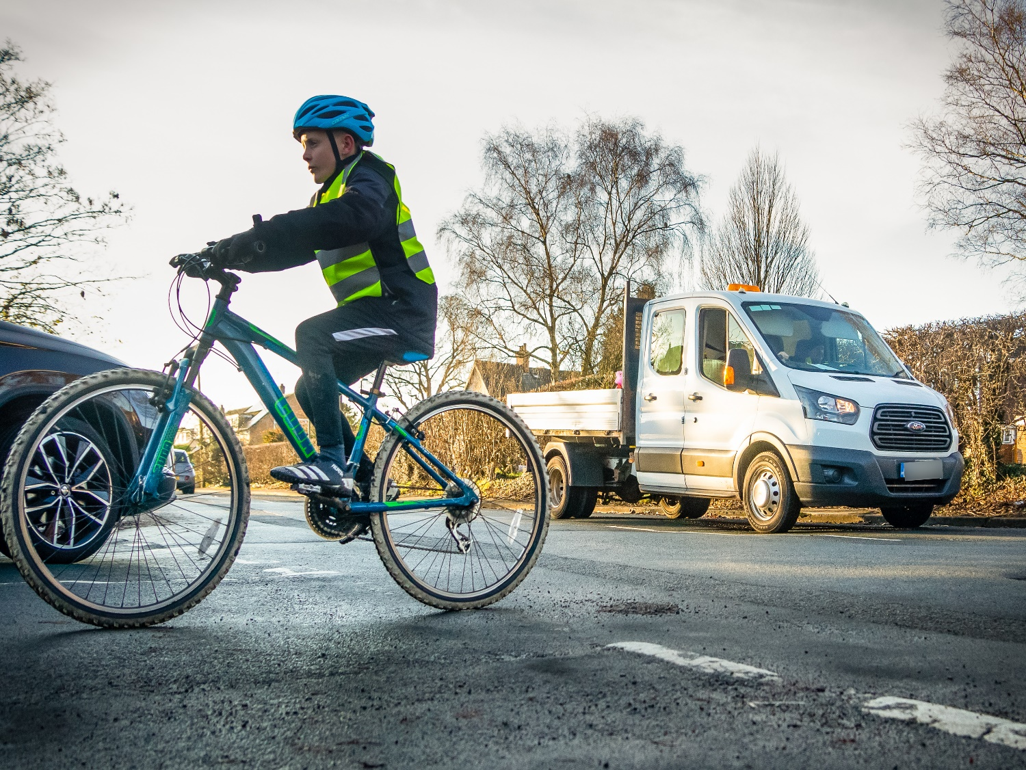

Appendix 1: Example Bikeability risk benefit assessment (site specific)

Venue | Albrighton Primary School |  |  |  | Contact details | 01234 5678910
Instructor (s): | A. N. Instructor |  |  |  | Date | 14/10/21
Traffic density | Low |  |  |  | Legal speed limit (s) | 30 in village limits. 60 out of Newhouse Lane
When observing independent riding can the riders be seen at all times? |  |  |  |  |  | Yes
Area allows for rider progression |  |  |  |  |  | Yes
Identify progression sites and order of progression:

Training area encompassed by black line below.
We will use Albert Road to introduce riders to the first activities, starting, stopping, and passing parked cars. Then progressing to Cross Road for progression and passing side roads. Snake riders to first training site (see blue highlights).
Junctions on Elm Road and Church Road to be used for the T-junction activities, with progression to High Street which is much busier (see red highlights).
Hazards  Slope on Church Road  Cross street is wide, with plenty of parked cars on one side, but extremely poor road surface.  Drivers often exceed 30 mph on Cross road  Visibility coming out of Whiston Close  Weather: At time of completion there has been heavy rain recently. There are large puddles on Newhouse Lane and some standing water on Charles Avenue. Also falling leaves along the edge of Newhouse Lane especially.  There is a roundabout between Pitchford Road and Albert Road (and on Cross Road) |  |  |  | Any necessary mitigation (consider the benefit)  Include as progression activity. Riders should be able to ride confidently with one hand and use gears. Riders will be able to build on systematic routine and make independent decisions based on steepness of slope, and whether to signal or keep hand on handlebars.  Discuss the importance of keeping a constant and predictable position when passing more than one vehicle e.g., did anyone notice where we rode when we passed the line of parked cars, and can anyone think why?  This is a route regularly used by riders. This is an opportunity to help introduce further decision making based on judging speed/distance. Engaging riders in discussions around increased speeds and speed limits (on Newhouse Lane), and the need to allow more time in decision making process, links in to further progression and Level 3 training.  High fences or hedges cannot be removed. Ensure riders discuss how to deal with this prior to attempting. Beneficial to reinforce riders’ understanding of the importance of choosing the appropriate position to see and be seen.  Question riders on approaching puddles and leaves. Draw out observation, road position and communication. Consider cycle control issues and use of brakes. Beneficial for riders to be actively engaged and encouraged to think for themselves about finding solutions to potential hazards, leading into planning a journey well later.  This is a single lane roundabout. It is regularly used by riders going to the park or school. We will snake round them and end the course by supporting riders to apply the 4CF through a SR at both.  If time and ability of riders allow, this will be an independent riding progression activity.  Beneficial to provide riders with an opportunity to ride independently and recap all previously learnt skills

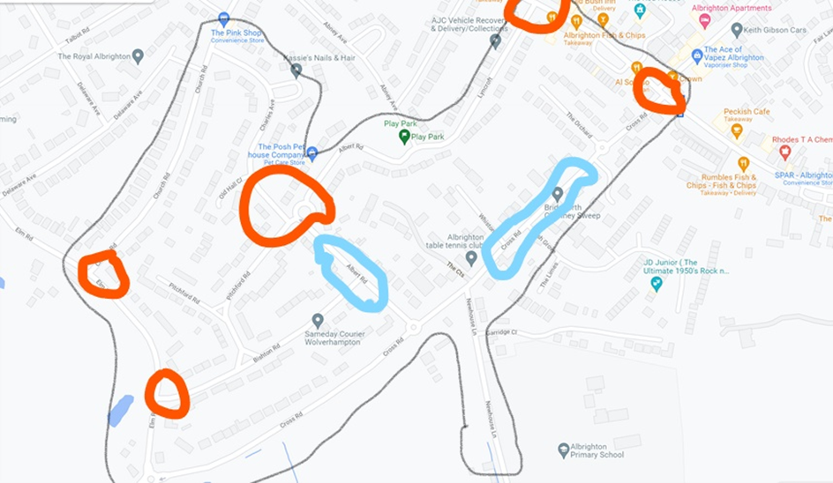
Alternatives to using a map view could include a comprehensive list of roads which make up the training area, or a photographic record of the locations and areas to be used.

Appendix 2: Example generic risk benefit assessment for Bikeability Level 2

ACTIVITY | Hazards | Who is at risk?
For cycling on single-lane roads and simple junctions with medium levels of traffic to develops skills and confidence. | - Collision with another road user.  - Collision with a pedestrian.  - Two riders may collide.  - A rider may fall off a cycle of their own accord.  - Mechanical failure.  - Adverse weather. | Participants  Pedestrians  Instructors  Other road users
How will the rider BENEFIT from this activity? | PRECAUTIONS in place to reduce the risk of harm.
- Increase rider’s propensity to cycle on roads.  - Learn to communicate (eye contact, signalling and road positioning) intensions to other road users.  - Riders understand priorities at junctions.  - Riders exposed to several types of road users and their behaviour e.g., large vehicles cutting corners.  - Development of fundamental skills and hazard awareness that will enable confident and safer cycling on the highway.  - Increase parent’s preparedness to allow children to cycle on roads.  - Develop the rider’s road safety knowledge.  - Trained children were better at perceiving and appropriately.  - Develop response to on-road hazards.  - Riders reported increased confidence cycling on the road after training.  - Use cycling as a standard form of transport. | - Completion of Bikeability Level 1 for all participants or ascertain their cycle control ability prior to being allowed on road.  - All instructors are trained to a high standard and that the content and structure of the Bikeability Delivery Guide (BDG) is followed.  - When training on the road the instructor: rider ratio must follow the Bikeability Delivery Guide and riders must always be under supervision.  - A Site / location risk assessment has is conducted prior to commencing activity.  - The use of the training and education program contained in the BDG is designed to embed competent, consistent, and confident control of the cycle.  - All cycles must be examined for safety purposes.  - Safeguarding  - Review weather forecast 24 hours prior to planned session.

*Identifying that the risk is reduced as far as is reasonably practicable is based on your judgement about whether the BENEFITS of the activity or opportunity outweigh the RISKS.
To be reviewed by The Bikeability Trust annually. Next review due May 2022

Appendix 3: Health and Safety Executive risk assessment template
The template below is an example from the HSE of a generic risk benefit assessment which may be used by Training providers
We have populated the template with some content specific to Bikeability settings.

What are the hazards? | Who might be harmed and how? | What are you already doing to control the risks? | What further action do you need to take to control the risks? | Who needs to carry out the action? | When is the action needed by? | Done
Collision with another road user. | Riders  Instructors  Members of the public  Other road users | Completion of Bikeability Level 1 for all participants or ascertain their cycle control ability prior to being allowed on road.  All instructors are trained to a high standard and that the content and structure of the Bikeability Delivery Guide (BDG) is followed.  When training on the road the instructor: rider ratio must follow the BDG and riders must always be under supervision.  A site / location risk assessment is conducted prior to commencing activity.  The use of the training and education program contained in the BDG is designed to embed competent, consistent, and confident control of the cycle.  All cycles must also be examined for safety purposes. | Instructors and riders will carry out dynamic risk  assessments during training to maintain  safety. | Instructors | Ongoing
Collision with a pedestrian.
Two riders may collide.
A rider may fall off a cycle of their own accord |  |  | Annual review of risk assessment standards by Bikeability | The Bikeability Trust:  Development and Operations Officer | 31st December 2021
Mechanical failure. |  |  | Review of Bikeability Delivery Guide. | The Bikeability Trust:  Development and Operations Officer | 31st December 2021
 |  |  | Annual instructor training and development | Training Provider | 31st December 2021
Adverse weather

Appendix 4: Clothing for cycle training

High visibility clothing for cycle training / Bikeability.

Training providers should reach their own policy position on the wearing of high visibility clothing during training and in reaching a position may wish to consider the following guidance.

Rule 59 in the current Highway Code (HC) contains advice on what people should wear when riding a cycle, including:

- Light-coloured or fluorescent clothing can help other road users to see you in daylight and poor light, while reflective clothing and/or accessories (belt, arm, or ankle bands) can increase your visibility in the dark.

The wearing of high visibility uniform may affect driver behaviour during a training session. It can work like a learner drivers 'L' plate and can cause other road users to be over cautious and interfere with their decision making, including giving way to riders where they would not normally do this. If riders are in their everyday clothes, they may be treated like ‘everyday riders,’ giving them a more realistic riding experience – a core aim of Bikeability.

The following article represents an alternative view: Cyclists cannot stop drivers overtaking dangerously, research study suggests (bath.ac.uk)

Appendix 5: Helmets for cycle training

Helmets for cycle training / Bikeability:

Each Training provider should reach their own policy position on the wearing of helmets during training. Training providers should consider the following:

Rule 59 of the Highway Code (HC) contains advice on what people should wear when riding a cycle, including: A cycle helmet which conforms to current regulations, is the correct size and securely fastened.

- The National Standard assessment criteria says: fasten a helmet correctly (if present), with assistance if necessary.
- The Bikeability Delivery Guide says: If helmets are used, identify the main adjustable parts (headband, Y straps, chin strap) and fit their own helmet (two-finger gap above brow and below chin, with assistance if required).

The following article and briefing paper represent views and research on the wearing of helmets:

Cycling helmets - RoSPA
Chris Boardman on helmets
Cycle helmets | Cycling UK

Glossary of Terms
Risk Management
Risk management is a formalised way of dealing with hazards. It is a logical process of evaluation where you weigh the potential costs of a risk against the potential benefits you might receive if you allowed that risk to stand uncontrolled. To better understand risk management, the terms “hazard” and “risk” need to be understood.
Risks: When we refer to risk in relation to occupational safety and health the most used definition is ‘risk is the likelihood that a person may be harmed or suffers adverse health effects if exposed to a hazard.’
Hazards: When we refer to hazards in relation to occupational safety and health the most used definition is ‘A Hazard is a potential source of harm or adverse health effect on a person or persons.
Generic risk benefit assessment: Generic risk assessments assess the hazards and risks involved in work tasks and activities. They can be used in various locations and by different providers for activities that are the same/similar, so they are often used as risk-assessment templates. This allows you to reduce duplication in your risk-management processes.
In this instance the Bikeability Trust supply the generic model to training providers and it is the responsibility of the training provider to amend them to make them site and setting specific
Site specific risk assessments: These are the most important types of risk assessments, as they are carried out for a specific activity in a specific location. This means they are completely relevant and should be effective at eliminating or controlling risks and keeping people safe. Think of these risk assessments like taking a deep dive into the health and safety of different activities and work sites.
These assessments may be completed after carrying out generic risk assessments to gain a better understanding of hazards and risk-control methods in the workplace.
You are legally required to take reasonable steps to mitigate risks and protect people from harm. Site-specific risk assessments can help you plan and implement control measures proportionate to the level of risk.
Dynamic risk assessment: Dynamic risk assessments are carried out on the spot, during unforeseen circumstances. If there are sudden, significant changes to the health and safety of the workplace or work activities, written risk assessments may not be applicable. Risks may need to be considered on the spot to assess whether it is safe for work to continue.
Qualitative Risk Assessments: Most risk assessments will fall under this category. When carrying out a qualitative assessment, the assessor will use their personal judgement to identify hazards around the workplace, assess risks and plan control measures. Risks may be classed as high, medium, or low-level after the assessor has considered both the probability and severity of the risk in question.

Quantitative Risk Assessments: This type of risk assessment uses quantitative tools and techniques to measure the level of risks. A risk matrix may be used so that a value can be assigned.

References and additional useful reading:

Health and Safety Executive Children’s play and leisure: promoting a balanced approach
Bath and Somerset playful_risk_-_risk_benefit.pdf (bathnes.gov.uk)
Royal Society for the prevention of accidents https://www.rospa.com/
The International School Grounds Alliance https://www.internationalschoolgrounds.org/risk/
Oxfordshire County Council Risk_benefit_assessment.pdf (oxfordshire.gov.uk)
Parkour https://parkour.uk/risk-benefit
The Young Report Common Sense, Common Safety (publishing.service.gov.uk)

