Example off-road site-specific risk benefit assessment

Pre-course checklist and off-road site-specific risk benefit assessment:
Venue: | Charlton Manor Primary School | Contact details: | Indus Rd, London SE7 7EF  02088765432
Instructor(s): | Davie Jones & John Smith | Date(s) of training: | 15th-19th January 2024
Instructor contact details: | 07891234567 & 07789123456 | Weather forecast: | 2-8 degrees C. Some light rain forecast.
Pre-course checklist:
Is the training area secure? |  | YES / NO
If not secure, please provide details:

Location of toilets/water/office/First Aid room (if present) checked? |  | YES / NO
Consent forms seen and checked? |  | YES / NO
If consent forms not seen and checked, please provide details:

Verbal handover received (if necessary)? |  | YES / NO / N/A
Cycles checked? |  | YES / NO
Helmets checked (if present)? |  | YES / NO / N/A
If cycles/equipment are not suitable, please provide details and action taken:

Minor adjustments performed on some of the cycles. Riders whose cycles have been assessed as not roadworthy and that couldn’t be repaired have been offered cycles delivered by the Council.

If any other action taken (e.g. additional staffing, weather, clothing, sunscreen, food/hydration), please provide details:

Cold and wet weather forecast. Riders have been advised to bring suitable clothing (including jackets and gloves).
Site-specific risk benefit assessment:
Risk benefit statement: Cycle training needs to be rider-led and realistic. Riders will encounter a range of hazards and risks when cycling. Exposure to these during training can benefit riders through providing them with real life experience in identifying and responding to hazards. This will help riders develop their cycling and progress towards the overall outcome of being able to ride competently and confidently in diverse environments. However, risks during training activities should be manageable, and training activities should only go ahead once necessary risk mitigation measures are in place.
Route to training site (if applicable):

Not applicable: Training will take place in the multi-use games area (MUGA) that is part of the school playground. Riders will be escorted there by school staff.
Training site information (description/photo/sketch):

The MUGA will be solely used for cycle training during the days that it is required for the Bikeability training; other children in the school will not be permitted to use the space.
The MUGA is approximately 35m x 15m The tarmac surface is flat. There is a gate to enter the MUGA that can be closed when needed. The playground that is next to the MUGA will occasionally be in use during the period of training.
Overhead image of MUGA:
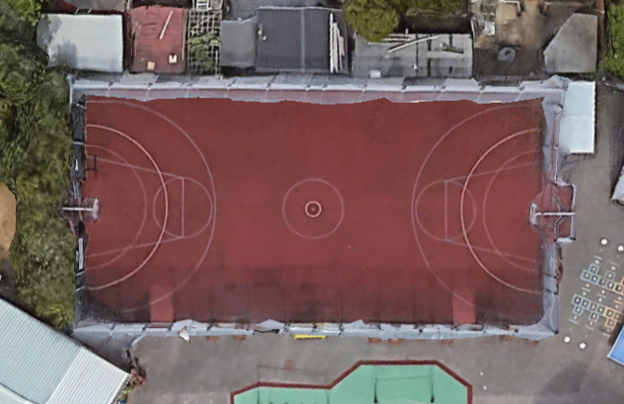

Hazards (list using bullet-points) |  | Mitigation measures (list using bullet-points and consider the benefits)
Gated access points  Small drains in the training area –are slippery when wet  White lines are slippery when wet  Noise and distraction from adjoining playground |  | Keep closed, and observe who is entering and exiting.  Avoid the drains during your activities, come them off if you have to use that area, also demonstrate how such surfaces are slippery and swerving technique.  Teach riders how to adjust their riding (including their braking and cornering technique) during wet/slippery conditions.  Where possible face riders away from the playground during activities. Use visual teaching techniques more where possible, for example demonstrations. Group discussions to take place in quieter sections of the MUGA where appropriate. Group responsibilities (including the need to focus wherever possible) to be agreed at the start of the course.

Example on-road site-specific risk benefit assessment
On-road site-specific risk benefit assessment
Risk benefit statement: Cycle training needs to be rider-led and realistic. Riders will encounter a range of hazards and risks when cycling. Exposure to these during training can benefit riders through providing them with real life experience in identifying and responding to hazards. This will help riders develop their cycling and progress towards the overall outcome of being able to ride competently and confidently in diverse environments. However, risks during training activities should be manageable, and training activities should only go ahead once necessary risk mitigation measures are in place.
Venue: | Charlton Manor Primary School |  | Contact details: | Indus Rd, London SE7 7EF  02088765432
Instructor(s): | Davie Jones & John Smith |  | Date(s) of training: | 15th-19th January 2024
Instructor contact details: | 07877056631 & 07837054632 |  | Weather forecast: | 2-8 degrees C. Some light rain forecast.
Brief description of training area and plans for the route and progression:

The training area consists primarily of residential streets that have variable traffic flows. The roads to be used for point-to-point independent riding activities have a 20mph limit.

The specific route and activities chosen for activities will be rider-led. However, in most cases, point-to-point independent riding activities will start on Canberra Road (by Charlton Park), before moving to Canberra Road/Hornfair Road and then progressing on from there. More accomplished riders may carry out activities at busier sites such as Marlborough Lane, Cemetery Lane and Little Heath.

Hazards |  | Mitigation measures (consider the benefit)
Hornfair Road passing Kashmir Road - Surface conditions are quite bumpy in places here. Full-width speed humps are pronounced. Parked cars and driveways. There is an entrance to the school opposite the junction.  Kashmir Road is very narrow at the junction so this can be a challenge if vehicles enter from the major road.  Wricklemarsh Road passing Woolacombe Road and Eastbrook Road - This is a staggered junction (offset crossroads) with moderate levels of traffic flow. Wricklemarsh is also a bus route, with buses turning in and out.  There is a bus stop near to the starting point on Wricklemarsh Road and speed humps on the major road. Road surface is bumpy in places.  The pavement on parts of Wricklemarsh is quite high so riders need to take care when finishing their journeys.  Marlborough Lane and Charlton Dene -  Moderate to high traffic volume. There is an uphill towards the junction. The major road is fairly wide at the junction but with insufficient width for drivers behind to undertake. There are parked cars on both roads. Traffic can quickly turn onto Marlborough Lane from the A207  Hornfair Road and Montcalm Road - There is a bend in Montcalm Road and insufficient space for people to overtake on this road.  Little Health and Park Drive -  This is a sometimes very busy major road that is used by buses and other large vehicles. The right turn into Park Drive incorporates passing Flamsteed Road.  Charlton Park Lane and Canberra Road -  Sight lines for road users entering the roundabout from Canberra Road are limited. There are usually parked cars on one side of Charlton Park Lane (Eastern section) and parked cars on both sides of Canberra Road. |  | Highlight this in the demonstration, and teach technique including weight on pedals and not sitting on the seat. Ask questions about ‘observation’. Ensure that control skills have been mastered at Level 1.  Make sure that riders are aware of this, teach dynamic road position, and understanding of priorities and speed with which you approach the junction.  Cover all instructing points needed during demonstration and questioning. Draw attention to the bus stop and route, and discuss interactions with the person driving the bus, and not to be intimidated by the size of the bus.  Coach riders to have their pavement side pedal up when stopping and pull in with care.  Use this as a progression site, discuss the gradient with riders and consider which gear they will select.  Riders need to ensure they make good and timely observations when starting their journeys. And on the approach, being ready to respond to changes in traffic volume.  Instruct riders not to pass the bend or go out of sight and ensure riders are using primary position, with frequent rear observations.  Use this as a progression site when riders are confident. There are good sight lines on the major road.  Vary your position accordingly and use paired riding, with one pair on the road at once.
Map of training area with highlighted areas for training:
Note: The red dots in the below training area are the location of the sites that are set out above for point-to-point independent riding activities:
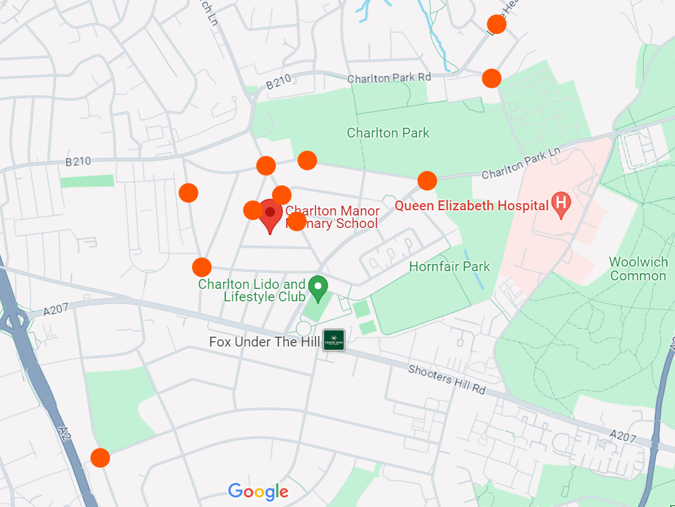
Alternatives to a map view could include a comprehensive list of roads which make up the training area, or a photographic record of the locations and areas to be used.

